**Project 1**

**Series Resonance Circuit**

**Objectives:**

The response of a circuit containing both inductors and capacitors in series or in parallel depends on the frequency of the driving voltage or current. This laboratory will explore one of the more dramatic effects of the interplay of capacitance and inductance, namely, resonance, when the inductive and capacitive reactances cancel each other. Resonance is the fundamental principle upon which most filters are based — filters that allow us to tune radios, televisions, cell phones, and a myriad of other devices deemed essential for modern living.

**EQUIPMENT:**

1. Function generator
2. Oscilloscope
3. Digital Multimeter

**Components:**

1. Resistor, 100 Ω
2. Resistor, 10 Ω
3. Inductor, 100mH
4. Capacitor, 0.01 µF

**Background**

The reactance of inductors increases with frequency: $X_{L}=2πfL$

The reactance of capacitors decreases with frequency: $X_{C}=\frac{1}{2πfC}$

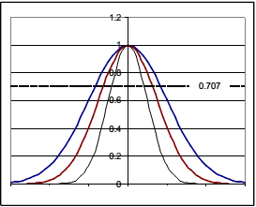In an LC circuit, whether series or parallel, there is some frequency at which the magnitudes of these two reactances are equal. That point is called resonance. Setting XL = XC, and solving for f, we find that the resonant frequency f0 of an LC circuit is: $f_{0}=\frac{1}{2π\sqrt{LC}}$

The frequency f has units cycles/second or sec­-1. The frequency may also be expressed as angular frequency, ω, where ω=2πf and has units radians/sec. Thus, the resonant frequency may also be written as:

$$ω_{0}=2πf_{0}=\frac{1}{\sqrt{LC}}$$

The resonant frequency is generally the highest point of a peak (or the deepest point of a valley) with bandwidth BW (cycles/sec) or β (radians/sec). The resonant frequency is also called the center frequency, because it is at the mid-point of the peak frequency response.

The lowest frequency (f1 or ω1) and the highest frequency (f2 or ω2) of the band are the “half-power points” at which the power is ½ that at the peak frequency. Since power goes like the square of the current, the current at the half-power points is $1/{\sqrt{2}}$ (= 0.707) times the current at the maximum. Thus, the bandwidth of a resonant circuit is the frequency range over which the current is at least 70.7% of the maximum.

BW = f2 – f1 or β = ω2 – ω1

As the bandwidth narrows, the circuit becomes more highly selective, responding to a narrow range of frequencies close to the center frequency. The sharpness (narrowness) of that resonant peak is measured by the quality factor Q. The quality factor is a unitless quantity that is defined as

$$Q=2π[\frac{maximum energy stored}{energy dissipated per cycle}]$$

In more practical terms, $Q=\frac{f_{0}}{BW} or Q=\frac{ω_{0}}{β}.$  
**Series Resonance**

For a series LC circuit, the current is the same throughout. What about the voltages? To visualize the concept of resonance, consider the simple series RLC circuit in Figure 1 operating at resonance, and its associated reactance diagram.

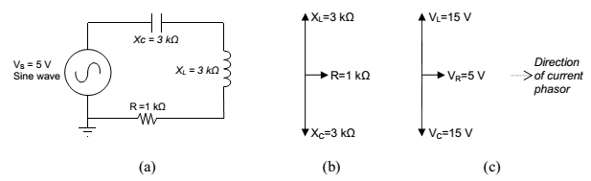

**Figure 1**

The phase shift caused by the capacitor is directly opposite the phase shift caused by the inductor; that is, they are 180° out of phase. Therefore, in the reactance phasor diagram (b) for the circuit, the two phasors point in opposite directions. At resonance, the magnitudes of the capacitor reactance and the inductor reactance are equal, so the sum of the two phasors is zero, and the only remaining impedance is due to the resistor. Notice in the voltage phasor diagram (c) that the voltage drop across the inductor and the capacitor may be quite large — bigger even than the source voltage — but those voltages are opposite in phase and so cancel each other out as voltages are summed around the circuit. Kirchhoff’s voltage law remains valid, and the generator’s voltage output is dropped entirely over the resistor R. Since at resonance the only impedance is the resistance R, the impedance of the series circuit is at a minimum, and so the current is a maximum. That current is VS /R. The source voltage and the current are in phase with each other, so the **power factor** = 1, and maximum power is delivered to the resistor. But what happens at neighboring frequencies? At lower frequencies, the inductor’s reactance decreases, and the capacitor has greater effect. At higher frequencies, the inductor dominates, and the circuit will take on inductive characteristics. How sharply defined is the resonance? How selective is it? We have said that for a resonant circuit, the quality factor Q is the ratio of the resonant frequency to the bandwidth. Thus, Q gives a measure of the bandwidth normalized to the frequency, thereby describing the shape of the circuit's response independent of the actual resonant frequency. $$Q=\frac{f_{0}}{BW}$$

We list here two other useful relationships for Q in a series resonant circuit. The first relates Q to the circuit’s capacitance, inductance, and total series resistance. $$Q=\frac{1}{R}\sqrt{\frac{L}{C}}$$ 
The value of R in this equation is the total equivalent series resistance in the circuit. This form of the equation makes it easy to see ways to optimize the Q for the desired circuit. Decreasing R, increasing inductance, or decreasing capacitance will all tend to make Q larger and increase the circuit's selectivity.

The second useful relationship for Q can be derived from the previous equation. Recall that $X_{L}=2πfL$ and $X_{C}=\frac{1}{2πfC}$. Then the previous equation can be rewritten as

$Q=\frac{1}{R}\sqrt{X_{L }{. X}_{C}}$.

Since at resonance the inductive and capacitive reactances are equal, this equation can be reduced to

$Q=\frac{X_{L}}{R}$ or $Q=\frac{X_{C}}{R}$

Where R is again the total equivalent series resistance of the circuit. Usually the XL form is used because the resistance of the inductor frequently is the dominant resistance in the circuit. An equivalent form of this last equation is

$Q=\frac{2πf_{0}L}{R}$ or $Q=\frac{1}{2πf_{0 }CR}$

**Summary of the Characteristics of RLC Series circuit**

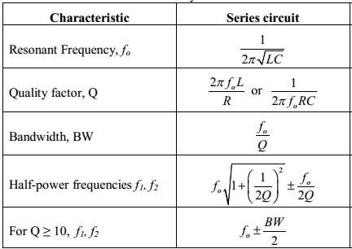

**Table 1**

**PROCEDURE**

1. Using DMM, measure the values of the following components: 0.01µF capacitor; 100 Ω resistor; 10 Ω resistor. Also measure the winding resistance RW of the 100mH inductor. Record the nominal and measured values in Table 2

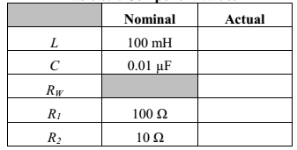

**Table 2**

1. For the circuit shown in Figure 2, calculate predictions for f0, Q, BW, f1, and f2. Don’t forget to include the impedance of the function generator (RS≈50Ω) and RW as part of the total resistance in the circuit. Record the results in the first “predicted” column in a table such as Table 3.

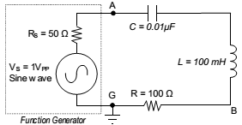

**Figure 2**

1. Construct the circuit shown in Figure 2. Adjust the function generator to generate a sine wave with voltage 1.0 VPP. Initially set the frequency to 1 kHz.
2. Connect oscilloscope CHANNEL 1 across the function generator (FGEN and GND) and confirm that the voltage is 1.0 VPP.
3. Connect oscilloscope CHANNEL 2 across the resistor R and observe the voltage.
4. Using your predicted values as a guide, adjust the frequency of the function generator to tune for resonance, as observed on CHANNEL 2 of the oscilloscope. Measure the resonant frequency fo on the oscilloscope, and record the value in the first “measured” column of Table 3.
5. Confirm that the voltage on CHANNEL 1 of the scope is 1.0 VPP, and adjust it if necessary. The current through the circuit and resistor R is proportional to the voltage across R. Record the voltage across resistor R

**Experimental Values**

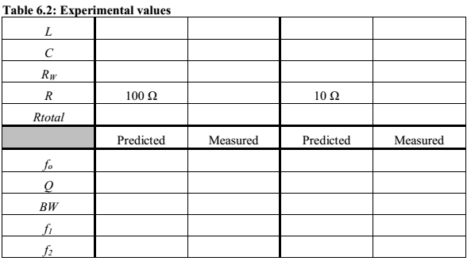

**Table 3.**

For steps 8 and 9, DO NOT adjust the voltage output of the function generator.

1. Reduce the frequency on the function generator until the voltage across R is 70.7% of the initial value. This is the lower half-power point f1. Record the measured frequency f1 in the first “measured” column of Table 3.
2. Increase the frequency through resonance and continue to increase it until the voltage across R is 70.7% of the value at resonance. This is the upper half-power point f2. Record the measured frequency f2 in the first “measured” column of Table 3.
3. Calculate the bandwidth BW = f2–f1. Record the result in the first “measured” column of Table 3.
4. Stop the function generator. Remove the 100Ω resistor from the circuit and replace it with the 10 Ω resistor measured earlier.
5. Calculate predictions for f0, Q, BW, f1, and f2 and record the results in the second “predicted” column in Table 3.
6. Start the function generator and, as before, adjust the function generator to create a sine wave with voltage 1.0 VPP.
7. Repeat steps 5 through 10, recording the measured values in the second “measured” column.
8. Fill out Table 4, calculating the percent differences between predicted and measured values.

**Percent difference**

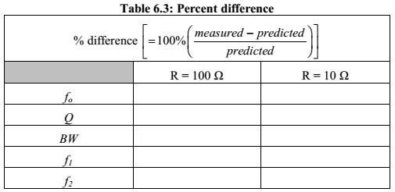

**Table 4**